Bus Topology:

Cisco Packet Tracer – Bus Topology

1. Open Cisco Packet Tracer
- Open Cisco Packet Tracer.
- Select the Logical workspace.
- You will see a blank workspace.

2. Add Four PCs
- At the bottom-left, click End Devices.
- Select PC.
- Add 4 PCs to the workspace.
- Arrange them in a straight line.
Example:
PC1 PC2 PC3 PC4
| | | |
+------------+------------+------------+
You can rename the PCs as PC1, PC2, PC3, and PC4.

3. Create the Bus Line
A bus topology has one main cable. All computers are connected to the same main cable.
[Terminator]
|
+---------------------------------------------+
| | | |
PC1 PC2 PC3 PC4
+---------------------------------------------+
|
[Terminator]
There should be a terminator at both ends of the bus.

4. Connect the PCs
If your Packet Tracer version provides a Bus/Coaxial cable:
- Click Connections at the bottom-left.
- Select the Bus/Coaxial cable.
- Create the main horizontal cable.
- Connect PC1 to the main cable.
- Connect PC2 to the main cable.
- Connect PC3 to the main cable.
- Connect PC4 to the main cable.
- Add a terminator at both ends.

5. Set IP Addresses
All PCs should be in the same network.

PC1
Go to:
PC1 → Desktop → IP Configuration
Enter:
IP Address: 192.168.1.1
Subnet Mask: 255.255.255.0

PC2
IP Address: 192.168.1.2
Subnet Mask: 255.255.255.0

PC3
IP Address: 192.168.1.3
Subnet Mask: 255.255.255.0

PC4
IP Address: 192.168.1.4
Subnet Mask: 255.255.255.0
For this simple practical, you do not need to enter a Default Gateway.

6. Check Connectivity Using Ping

Step 1 – Open PC1 Command Prompt
- Click PC1.
- Go to Desktop.
- Click Command Prompt.

Step 2 – Ping PC2
Type:
ping 192.168.1.2
Press Enter.
If the connection is working, you should see:
Reply from 192.168.1.2
Reply from 192.168.1.2
Reply from 192.168.1.2
Reply from 192.168.1.2
This means PC1 can communicate with PC2.

Step 3 – Ping PC3
From PC1, type:
ping 192.168.1.3
If you receive replies, PC1 can communicate with PC3.

Step 4 – Ping PC4
From PC1, type:
ping 192.168.1.4
If you receive replies, PC1 can communicate with PC4.

7. Test from Other PCs

From PC2
ping 192.168.1.1
ping 192.168.1.3

From PC3
ping 192.168.1.1
ping 192.168.1.4

From PC4
ping 192.168.1.1
ping 192.168.1.2
If you get Reply from..., the connectivity is successful.

8. If Ping Fails
Check these points:
- Check the IP addresses.
- Check the Subnet Mask.
- Check whether the cables are connected properly.
- Check the bus cable.
- Check the terminators.
- Make sure all PCs are in the same network.

Final Bus Topology
[Terminator]
|
+------------------------------------------------+
| | | |
PC1 PC2 PC3 PC4
| | | |
+------------------------------------------------+
|
[Terminator]

Expected Result
All PCs should be able to communicate with each other using the ping command.
Example:
PC1 → ping 192.168.1.2
PC1 → ping 192.168.1.3
PC1 → ping 192.168.1.4
Expected result:
Reply from 192.168.1.x
This confirms that the network connectivity is working.
Important: In some Cisco Packet Tracer versions, a traditional Bus/Coaxial topology is not directly supported. If you send me a screenshot of your Packet Tracer Connections menu, I can tell you exactly which cable/icon to select in your version.
Star Topology:
Sure. Here is the same practical for Star Topology in simple English, with the diagram and screenshot-style guide.
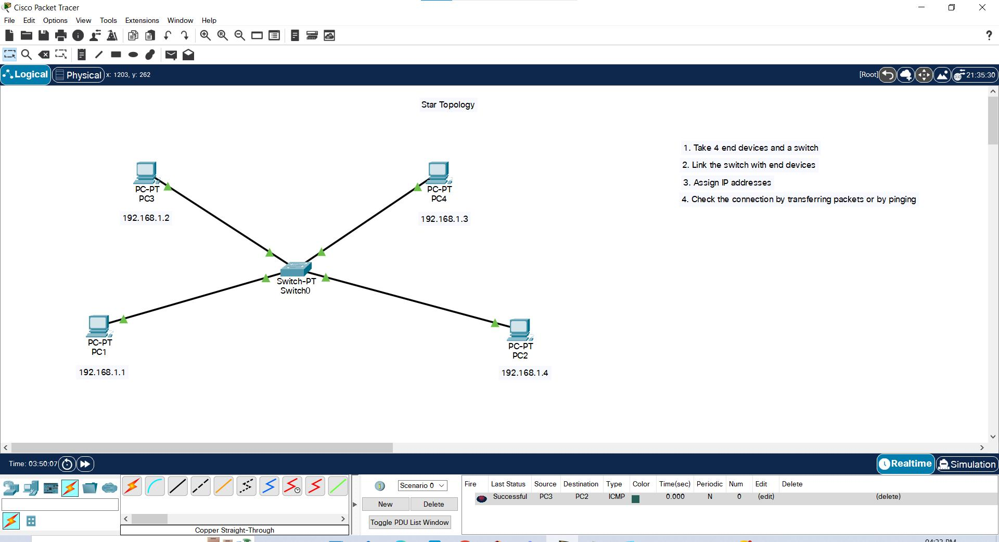
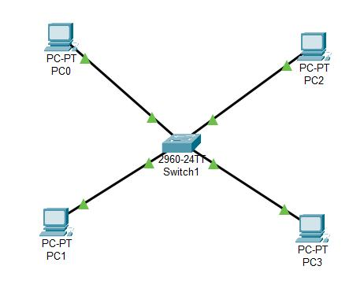
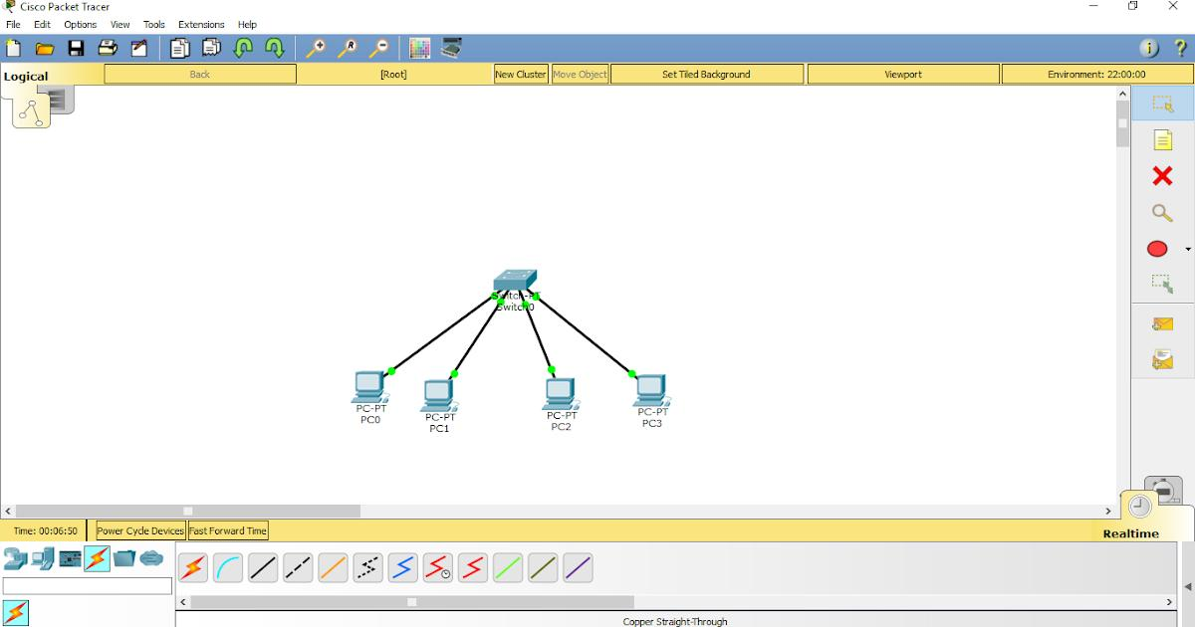
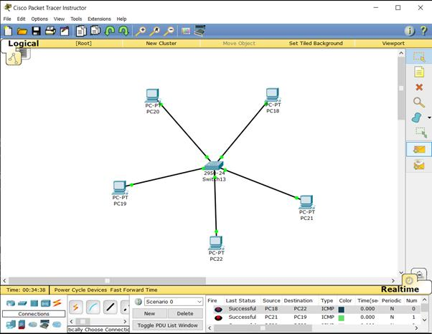
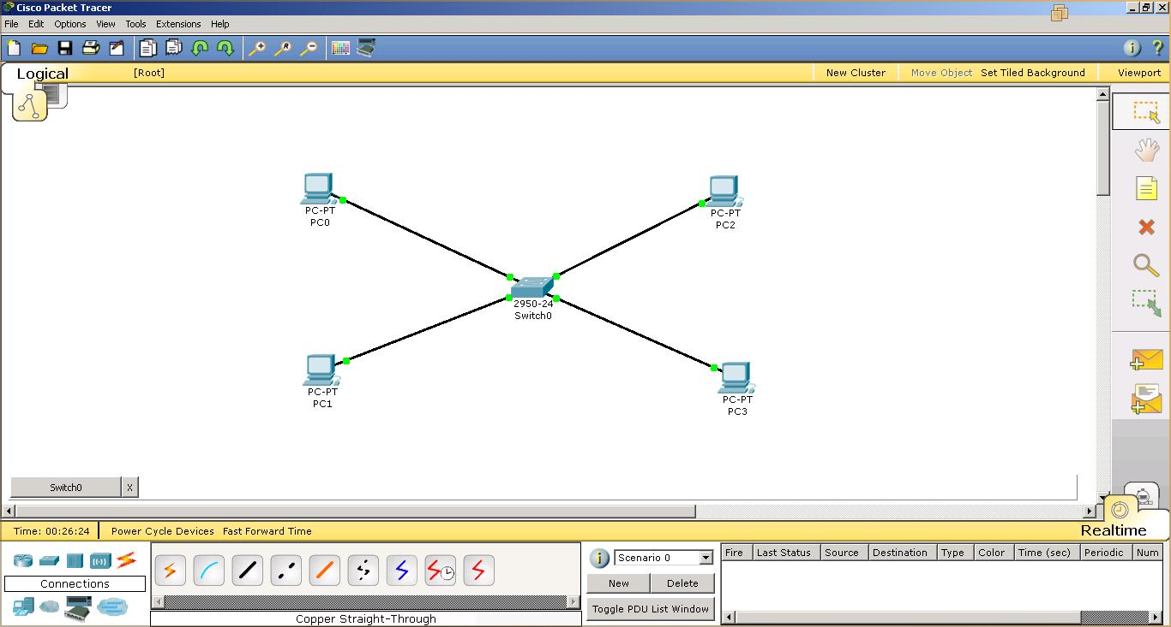

Cisco Packet Tracer – Star Topology

1. Open Cisco Packet Tracer
- Open Cisco Packet Tracer.
- Select the Logical workspace.
- You will see a blank workspace.

2. Add One Switch
At the bottom-left:
Network Devices → Switches
Select:
2960 Switch
Place it in the center of the workspace.

3. Add Four PCs
Go to:
End Devices → PC
Add 4 PCs.
Arrange them around the switch:
PC1
|
|
PC2 ------------- Switch ------------- PC3
|
|
PC4
This is called a Star Topology because all devices are connected to one central device.

4. Connect the PCs to the Switch
- Click Connections at the bottom-left.
- Select Copper Straight-Through cable.
- Click PC1.
- Select FastEthernet0.
- Click the Switch.
- Select FastEthernet0/1.
Now connect the other PCs:
PC1 → Switch Fa0/1
PC2 → Switch Fa0/2
PC3 → Switch Fa0/3
PC4 → Switch Fa0/4
Final diagram:
PC1
|
|
|
PC2 ---------------- SWITCH ---------------- PC3
|
|
|
PC4

5. Set IP Addresses
All PCs should be in the same network.

PC1
Go to:
PC1 → Desktop → IP Configuration
Enter:
IP Address: 192.168.1.1
Subnet Mask: 255.255.255.0

PC2
IP Address: 192.168.1.2
Subnet Mask: 255.255.255.0

PC3
IP Address: 192.168.1.3
Subnet Mask: 255.255.255.0

PC4
IP Address: 192.168.1.4
Subnet Mask: 255.255.255.0
You do not need to enter a Default Gateway for this simple network.

6. Check Connectivity Using Ping

From PC1 to PC2
- Click PC1.
- Go to Desktop.
- Click Command Prompt.
- Type:
ping 192.168.1.2
Press Enter.
You should get:
Reply from 192.168.1.2
Reply from 192.168.1.2
Reply from 192.168.1.2
Reply from 192.168.1.2
This means PC1 and PC2 are connected successfully.

From PC1 to PC3
ping 192.168.1.3

From PC1 to PC4
ping 192.168.1.4
If you get Reply from..., the connection is working.

7. Test from Other PCs

From PC2
ping 192.168.1.1
ping 192.168.1.3

From PC3
ping 192.168.1.1
ping 192.168.1.4

From PC4
ping 192.168.1.1
ping 192.168.1.2

8. Expected Result
All four PCs should be able to communicate with each other through the central switch.
PC1
|
|
|
PC2 ------------- SWITCH ------------- PC3
|
|
|
PC4
If all ping commands show Reply from..., your Star Topology is working successfully.

9. If Ping Fails
Check the following:
- Check the IP addresses.
- Check the subnet mask.
- Make sure you used Copper Straight-Through cable.
- Check that all cables are connected to the correct switch ports.
- Make sure the switch is connected to all four PCs.
- Make sure all PCs are in the same network.

Port Connection Table
Device | Switch Port
PC1 | Fa0/1
PC2 | Fa0/2
PC3 | Fa0/3
PC4 | Fa0/4

IP Address Table
PC | IP Address | Subnet Mask
PC1 | 192.168.1.1 | 255.255.255.0
PC2 | 192.168.1.2 | 255.255.255.0
PC3 | 192.168.1.3 | 255.255.255.0
PC4 | 192.168.1.4 | 255.255.255.0
Screenshot guide: The generated screenshot-style diagram above shows the exact flow: Add Switch + 4 PCs → Connect with Copper Straight-Through → Set IPs → Open Command Prompt → Ping → Check Reply.

Ring Topology
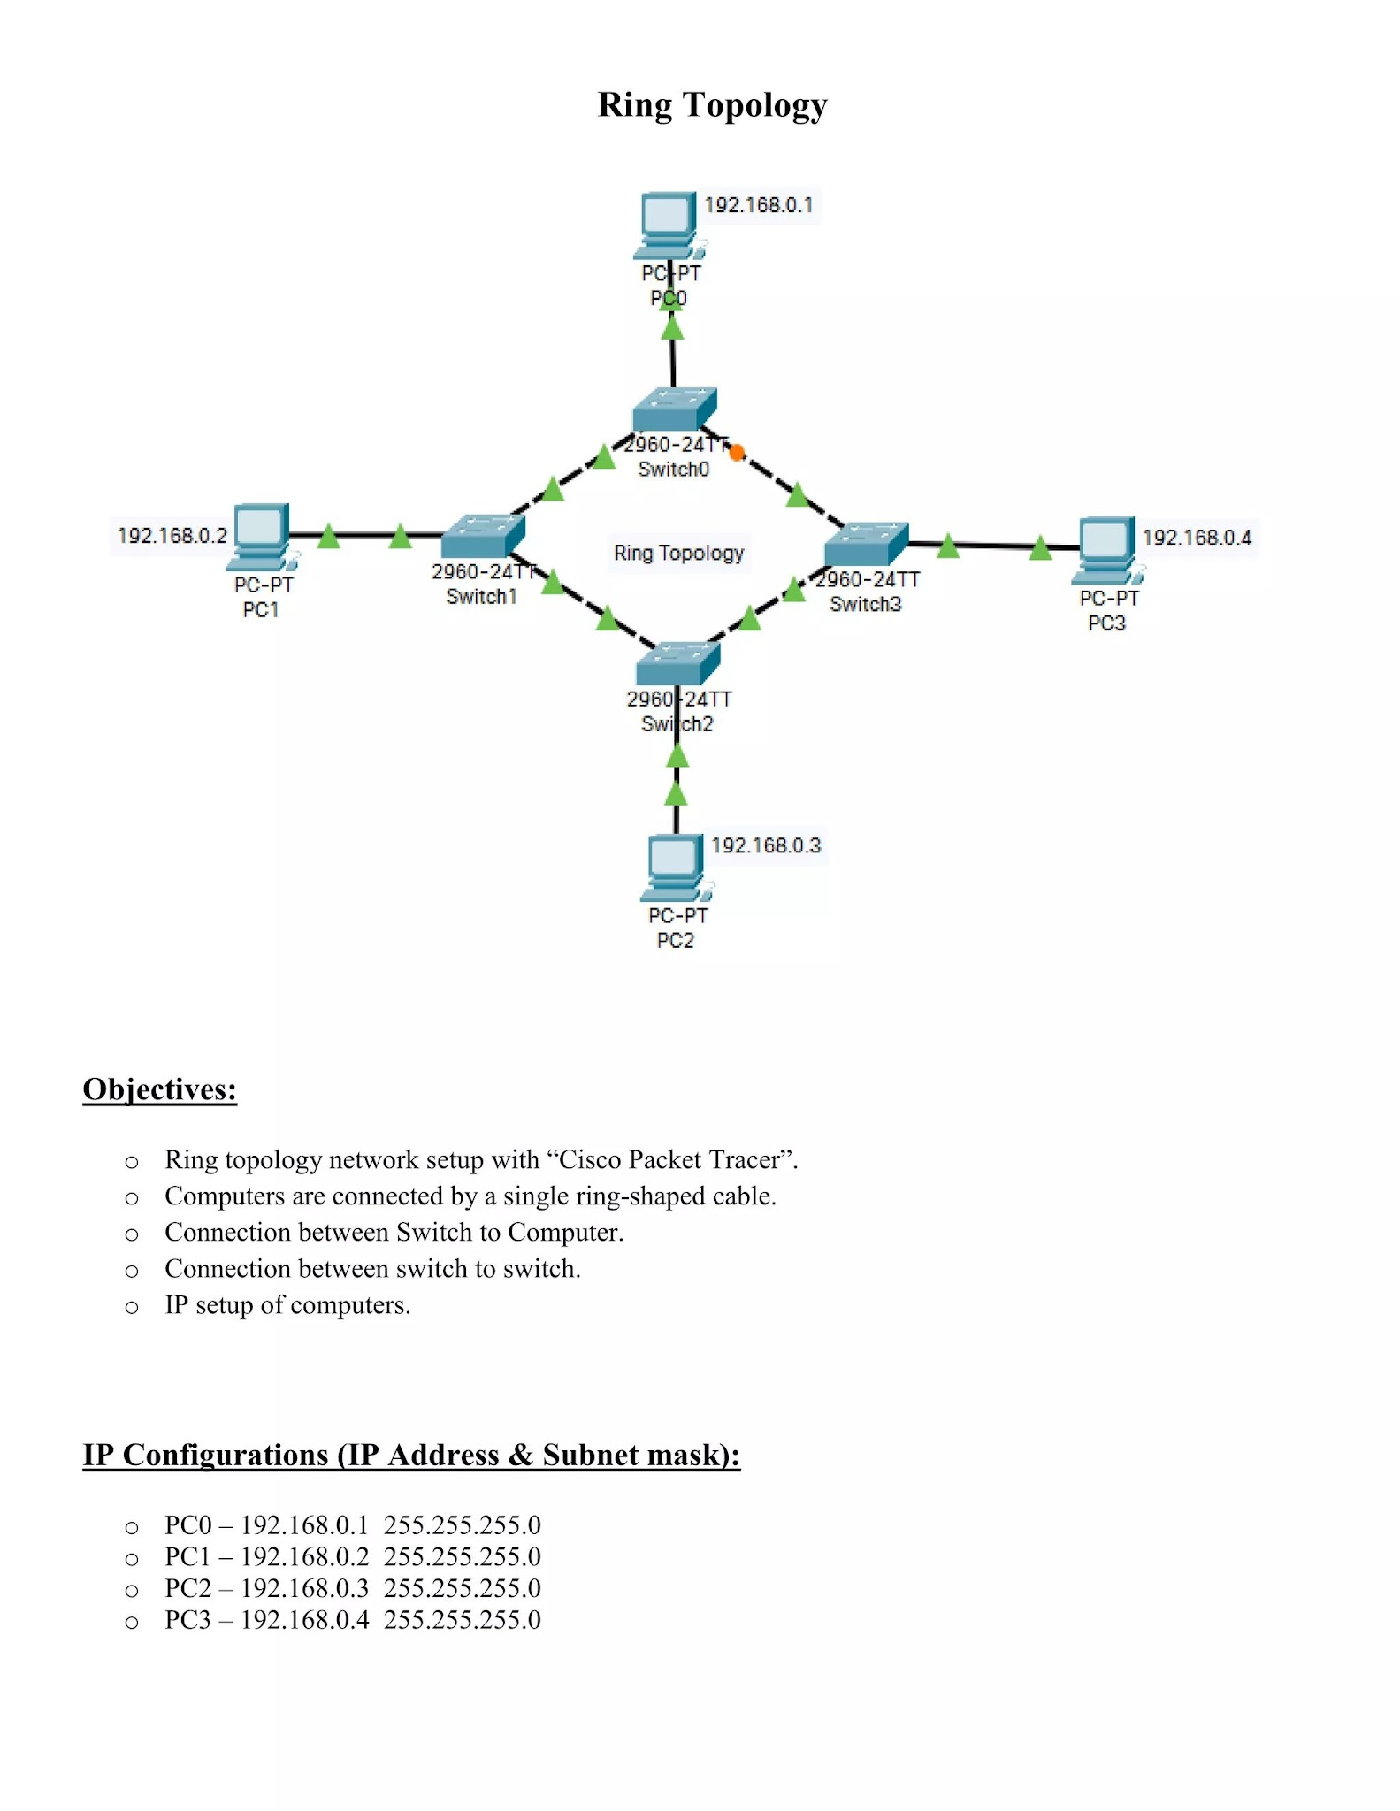
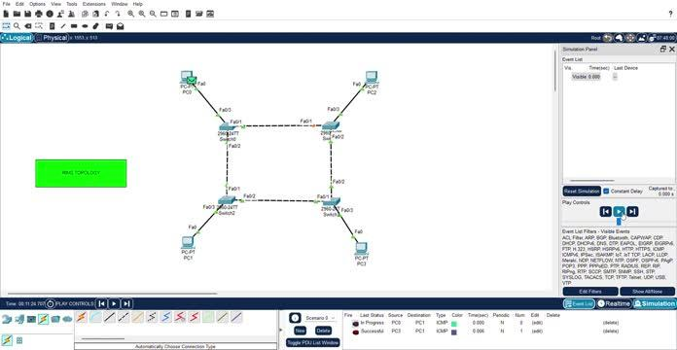

Cisco Packet Tracer – Ring Topology

1. Open Cisco Packet Tracer
- Open Cisco Packet Tracer.
- Select the Logical workspace.
- You will see a blank workspace.

2. Add Four Switches
Go to:
Network Devices → Switches
Select:
2960 Switch
Add 4 switches to the workspace.
Rename them:
S1
S2
S3
S4
Arrange them in a square or ring shape:
S1
/ \
/ \
S4 S2
\ /
\ /
S3

3. Add Four PCs
Go to:
End Devices → PC
Add 4 PCs.
Connect one PC to each switch.
PC1
|
S1
/ \
/ \
S4 S2
| |
PC4 PC2
\ /
\ /
S3
|
PC3

4. Connect PCs to Switches
Click:
Connections → Copper Straight-Through
Connect:
PC1 → S1
PC2 → S2
PC3 → S3
PC4 → S4
Use the following switch ports:
PC1 → S1 Fa0/1
PC2 → S2 Fa0/1
PC3 → S3 Fa0/1
PC4 → S4 Fa0/1

5. Connect the Switches in a Ring
Now connect the switches with Copper Cross-Over cable.
Connect:
S1 → S2
S2 → S3
S3 → S4
S4 → S1
Use these ports:
S1 Fa0/2 → S2 Fa0/2
S2 Fa0/3 → S3 Fa0/2
S3 Fa0/3 → S4 Fa0/2
S4 Fa0/3 → S1 Fa0/3
The final ring should look like:
S1
/ \
/ \
S4 S2
\ /
\ /
S3
The important point is:
Every switch must be connected to two other switches.

6. Set IP Addresses
All PCs should be in the same network.

PC1
Go to:
PC1 → Desktop → IP Configuration
Enter:
IP Address: 192.168.1.1
Subnet Mask: 255.255.255.0

PC2
IP Address: 192.168.1.2
Subnet Mask: 255.255.255.0

PC3
IP Address: 192.168.1.3
Subnet Mask: 255.255.255.0

PC4
IP Address: 192.168.1.4
Subnet Mask: 255.255.255.0
For this simple network, Default Gateway is not required.

7. Wait for the Connections to Become Green
After connecting the devices, wait for a few seconds.
The connection indicators should become green.
If the links are orange for a short time, wait.
If they remain red, check the cable and port connections.

8. Check Connectivity Using Ping

Test PC1 → PC2
- Click PC1.
- Go to Desktop.
- Open Command Prompt.
- Type:
ping 192.168.1.2
Press Enter.
You should get:
Reply from 192.168.1.2
Reply from 192.168.1.2
Reply from 192.168.1.2
Reply from 192.168.1.2
This means PC1 can communicate with PC2.

9. Test PC1 → PC3
From PC1 Command Prompt:
ping 192.168.1.3
You should get:
Reply from 192.168.1.3

10. Test PC1 → PC4
Type:
ping 192.168.1.4
You should get:
Reply from 192.168.1.4

11. Test from Other PCs

From PC2
ping 192.168.1.1
ping 192.168.1.3

From PC3
ping 192.168.1.1
ping 192.168.1.4

From PC4
ping 192.168.1.1
ping 192.168.1.2
If you receive Reply from..., the connectivity is working.

12. Final Ring Topology
Your final topology should look similar to this:
PC1
|
S1
/ \
/ \
S4 S2
| |
PC4 PC2
\ /
\ /
S3
|
PC3
The four switches form a closed ring:
S1 → S2 → S3 → S4 → S1

13. Device Connection Table
Device | Connected To
PC1 | S1
PC2 | S2
PC3 | S3
PC4 | S4
S1 | S2 and S4
S2 | S1 and S3
S3 | S2 and S4
S4 | S3 and S1

14. IP Address Table
PC | IP Address | Subnet Mask
PC1 | 192.168.1.1 | 255.255.255.0
PC2 | 192.168.1.2 | 255.255.255.0
PC3 | 192.168.1.3 | 255.255.255.0
PC4 | 192.168.1.4 | 255.255.255.0

15. If Ping Fails
Check these points:
- Check the IP addresses.
- Check the subnet mask.
- Check the cables.
- Check the switch ports.
- Make sure every switch is connected to two other switches.
- Make sure the ring is closed.
- Wait for the links to become green.

Expected Result
All four PCs should be able to communicate with each other.
For example:
PC1 → PC2 Successful
PC1 → PC3 Successful
PC1 → PC4 Successful
PC2 → PC3 Successful
PC2 → PC4 Successful
PC3 → PC4 Successful
A successful ping shows:
Reply from 192.168.1.x
This confirms that the Ring Topology is working successfully.

Mesh Topology – Cisco Packet Tracer Steps

Step 1: Add PCs
- Open Cisco Packet Tracer.
- Go to End Devices.
- Select PC.
- Drag and drop 4 PCs into the workspace.
- Rename them:
  - PC1
  - PC2
  - PC3
  - PC4

Step 2: Add Extra Ports
- Click PC1.
- Open Physical tab.
- Turn Power OFF.
- Add network modules to get extra Ethernet ports.
- Turn Power ON.
- Repeat the same steps for PC2, PC3, and PC4.

Step 3: Connect PC1 to PC2
- Click Connections (lightning icon).
- Select Copper Cross-Over.
- Click PC1 → select an available FastEthernet port.
- Click PC2 → select an available FastEthernet port.

Step 4: Connect PC1 to PC3
PC1 → PC3
Use another available port on both PCs.

Step 5: Connect PC1 to PC4
PC1 → PC4
Use another available port.

Step 6: Connect PC2 to PC3
PC2 → PC3

Step 7: Connect PC2 to PC4
PC2 → PC4

Step 8: Connect PC3 to PC4
PC3 → PC4

Final Connections
PC1 ───── PC2
│ \ /│
│ \ / │
│ \ / │
│ \ / │
PC3 ───── PC4
There should be 6 direct connections in total.

Step 9: Test the Topology
- Click PC1.
- Go to Desktop → Command Prompt.
- Use ping with the IP address of another PC.
- Repeat the test from other PCs.
- If you receive Reply from..., the connection is working.

